OpenCable™
OCAP 1.1.2 <tru2way> SDK Release 0.3.001
QuickStart Guide

Notice
This document is an effort for the benefit of the OpenCable Team. Neither CableLabs, nor any other entity participating in the creation of this document, is responsible for any liability of any nature whatsoever resulting from or arising out of use or reliance upon this document by any party. This document is furnished on an AS-IS basis and neither CableLabs, nor other participating entity, provides any representation or warranty, express or implied, regarding its accuracy, completeness, or fitness for a particular purpose.
© Copyright 2009 Cable Television Laboratories, Inc.
All rights reserved.
Version History

Version Number | Date | Contributor | Description
V1.0 | 11/11/09 | Mark Millard | 1st draft

Overview
This document provides a guide for using the tru2way™ Software Development Kit, called <tru2way> Workbench (TWB). The <tru2way> SDK is used to develop and debug OCAP applications using the OCAP Reference Implementation (OCAP-RI) from Cable Television Laboratories, Inc.
The tru2way™ Software Development Kit has the following system requirements:
- Microsoft Windows® XP
- 2.4 GHz Intel Core™ Duo or higher is recommended
- 2GB RAM (4 GB is recommended)
- a video card with OpenGL 3D acceleration
- 300 MB of free hard disk space
- Eclipse 3.4.2

SDK Description
The <tru2way> SDK is built upon the Eclipse Integrated Development Environment. The Eclipse IDE is an open-source tools platform providing the foundation and interface for TWB. Backed by the Eclipse Consortium and contributors such as IBM and Red Hat, the Eclipse Platform has become the IDE of choice for an increasing number of software developers. The plug-in architecture ensures that plug-ins written by other providers will work within <tru2way> SDK, giving the application developer the flexibility to customize the development environment to fit his/her needs.
The tru2way™ Software Development Kit is developed in conjunction with the OCAP Reference Implementation. The features accessible to the OCAP application developer are constrained by the features present in the OCAP Stack reference implementation and RI Emulator. These features, the state of the stack implementation, are not discussed in this document.
<tru2way> SDK includes the following core features:
- OCAP Project
- Xlet Service Configuration
- Channel Map Editor
- OCAP Reference Implementation Emulator
- Application execution in both Run and Debug configurations

OCAP Application Development
The workflow for creating and debugging an OCAP application is shown in Figure 1.
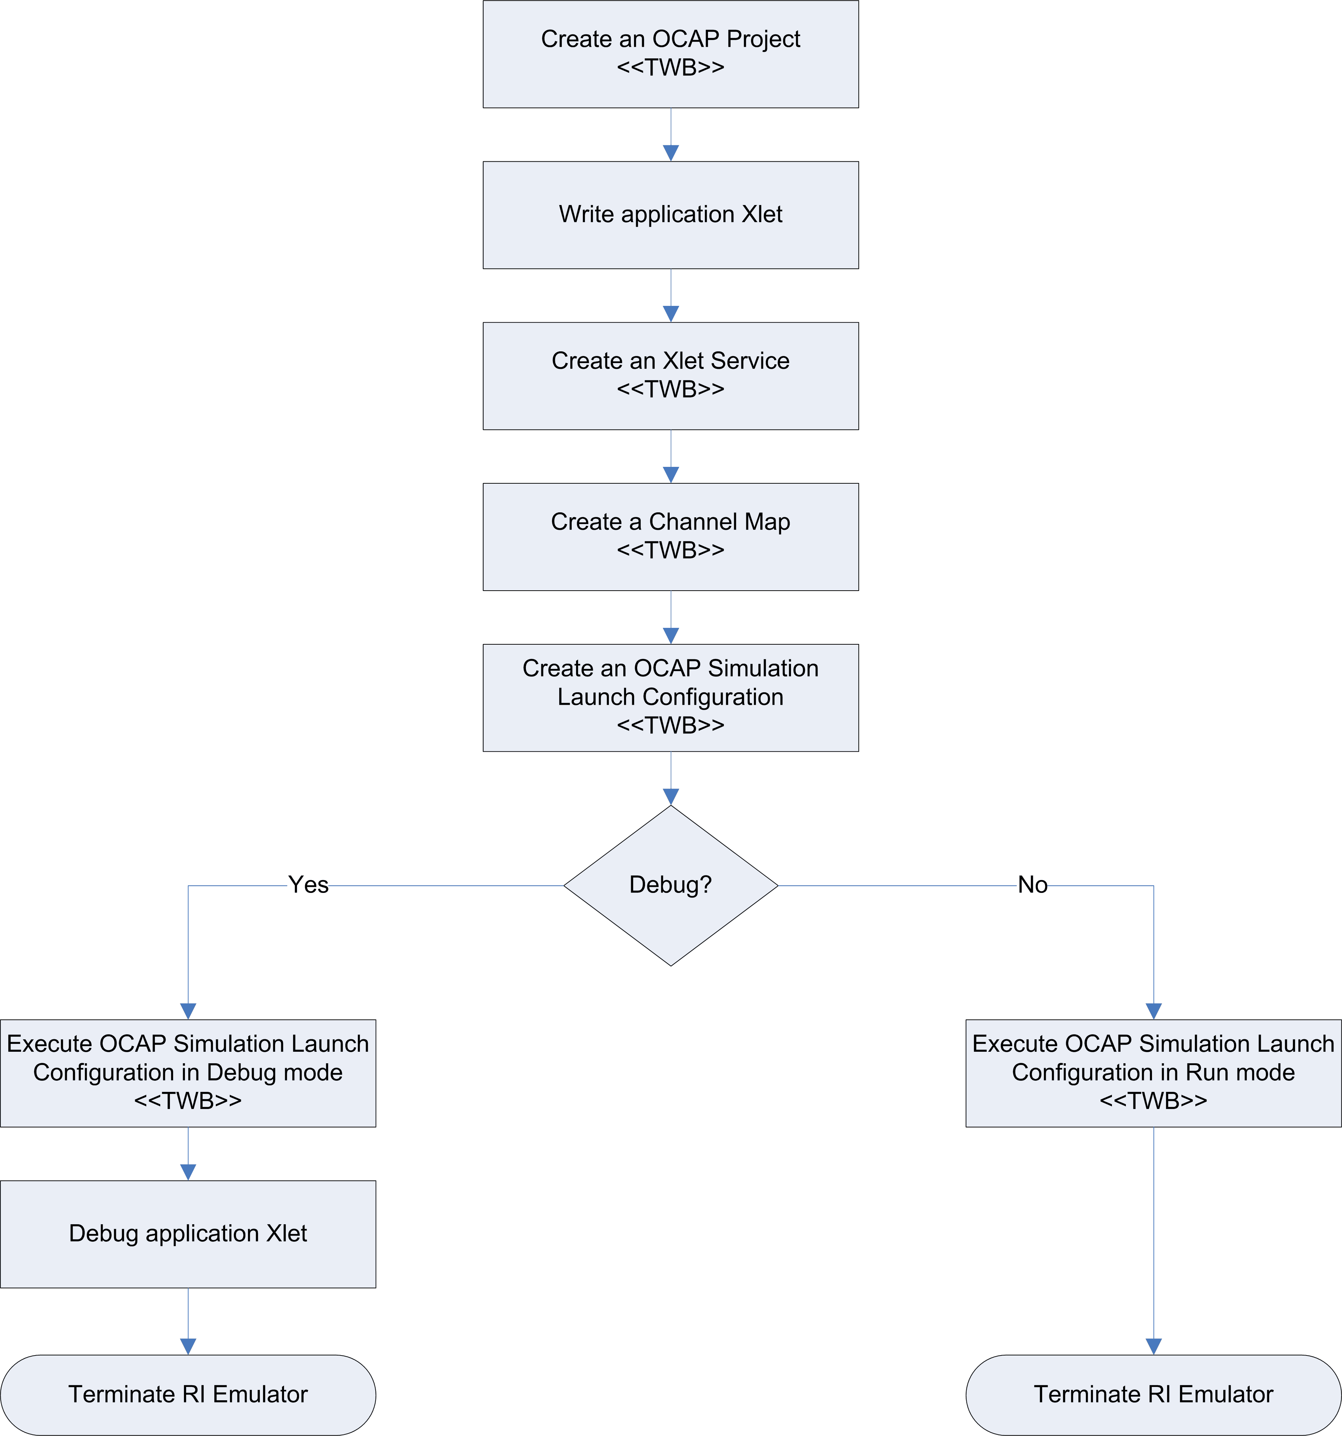
Figure 1: <tru2way> SDK Workflow

Creating an OCAP Project
The first thing an OCAP application developer will do with <tru2way> SDK will be to create a project. A project is used to manage and build the application software. TWB provides a “New OCAP Wizard” to quickly create an OCAP Project and establish a build environment for compiling OCAP-compliant code.
To create an OCAP Project:
- Select “New->Project…” from the “File” menu. This will bring up the project dialog panel shown in Figure 2.
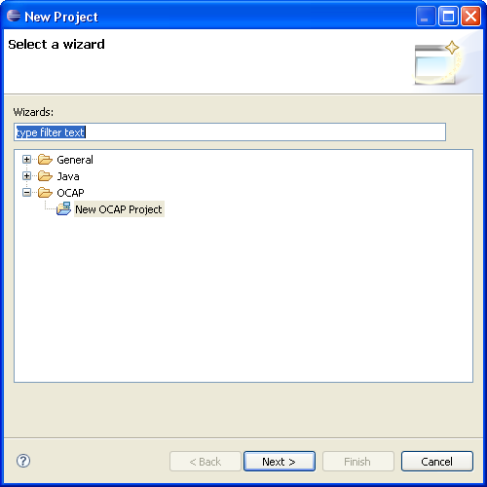
Figure 2: New Project Wizard
- Select “New OCAP Project” from the OCAP category.
- Select “Next>”. This will bring up the “New OCAP Project” wizard. See Figure 3.
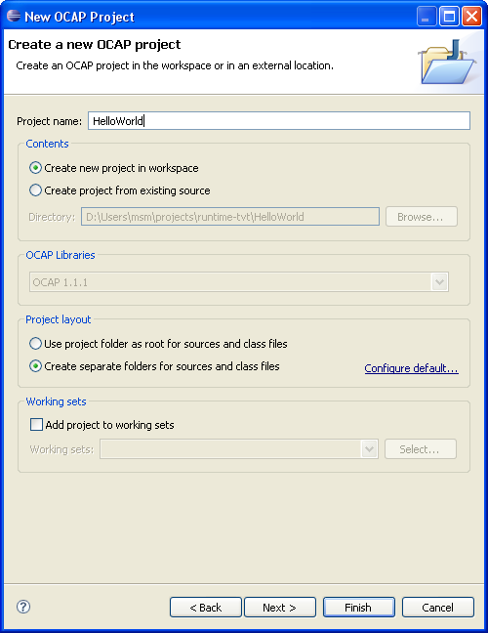
Figure 3: New OCAP Project Wizard
- Provide a project name by typing it into the text box.
- Select “Finish”. This will create a project in the Package Explorer using the default build configuration. By default, code will be generated for a SimpleXlet configuration which contains the standard entry points for an OCAP Xlet. The name of the project will be the same as the text specified in step 4. Figure 4 shows the result of the newly created project.
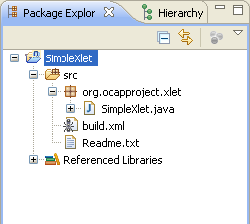
Figure 4: Simple Xlet Generated Source

Advanced Features

Selecting an Application Template
With this release of the <tru2way> SDK (v 0.3.001), the application developer may now select between two application templates, the Simple Xlet and the HelloWorld Xlet. To select one of these templates, the developer should select “Next>” in the “New OCAP Project” wizard dialog above (instead of “Finish”). Figure 5 below displays the application template dialog page.
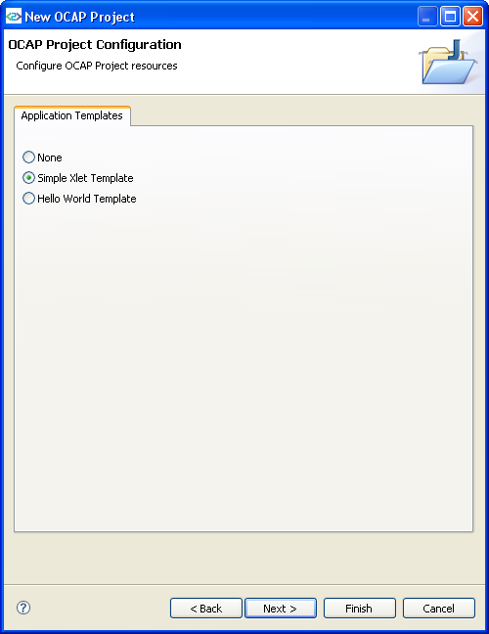
Figure 5: Application Templates
Selecting “None” will generate an empty OCAP Project (as in version 0.2.001 of the SDK).

Configuring Java Settings
Usually the default Java settings for the OCAP Project will be sufficient enough to build and test your OCAP applications. However, there is an option in the OCAP Project wizard to modify these settings. To configure the Java settings in the OCAP Project simply select the “Next>” button on the Application Template wizard page. Figure 6 shows the user interface for modifying the OCAP Project Java configuration.
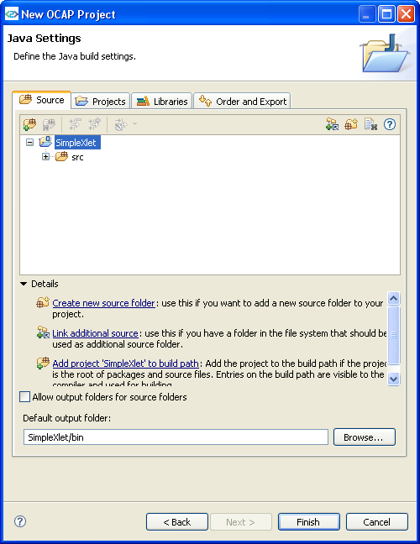
Figure 6: OCAP Project Java Configuration Settings

Creating an Xlet Service
An Xlet Service is the means by which the OCAP application XAIT is created in the <tru2way> SDK. In order to run the OCAP Project software, the application developer must first create an Xlet Service Configuration. This is done by selecting the Xlet Service icon from the main toolbar menu. The Xlet Service icon looks like:
Selecting this button will activate a drop-down menu. Select “Open Services Dialog…” to start the Xlet Service Configuration wizard. Figure 7 shows the Service Configurations panel.
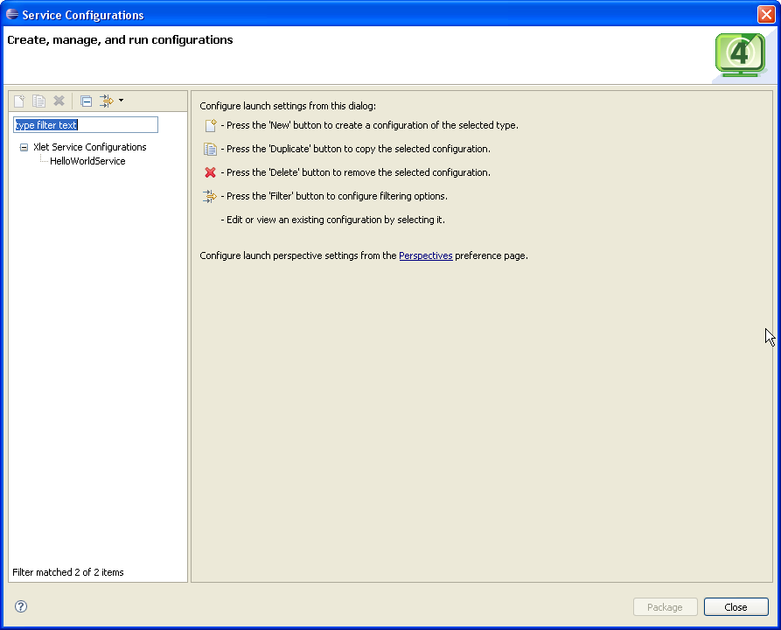
Figure 7: Xlet Service Configuration Wizard
To create a service, do the following:
- On the left-hand side of the panel, you should see “Xlet Service Configurations”. Select it.
- Create a new configuration by pressing the “New” button to create a configuration of the selected type. This will bring up a user interface consisting of three tabs, “Main”, “Permissions” and “Common”. See Figure 8.
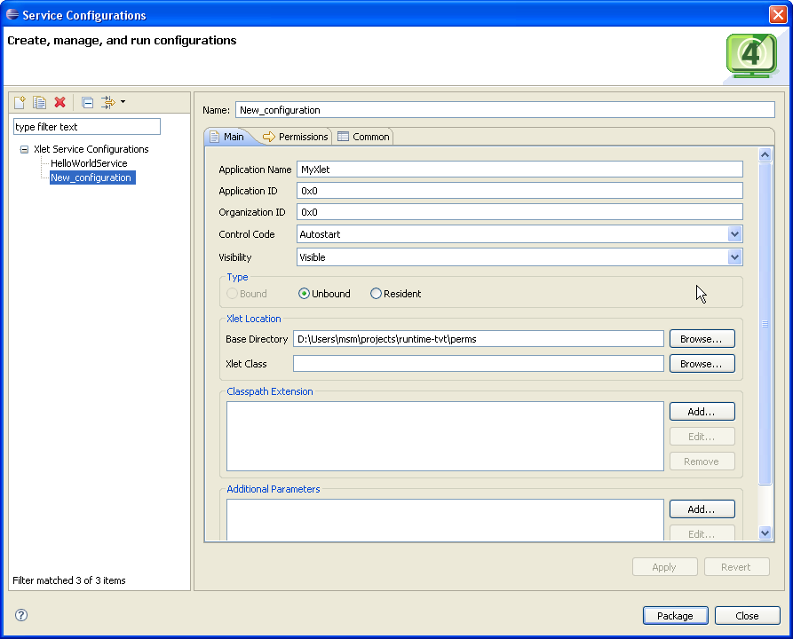
Figure 8: Xlet Service Configuration Dialog
- In the “Main” tab, fill out the properties for the XAIT. See Figure 9 for an example.
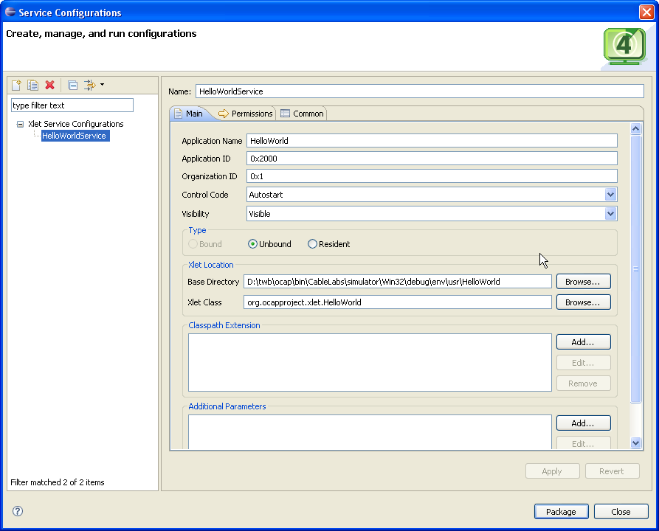
Figure 9: Xlet Service Configuration Example
- For now, ignore the “Permissions” and “Common” tabs. Select “Apply” to create an Xlet Service launch configuration. Select “Close”
Note: The “Permissions” tab is used to specify the fields in a Permission Request File. Use this interface to identify the permissions required to run your application. Selecting the “Package” button will generate the ocap.xxxx.perm file necessary for running your application. The generated file will be placed in the Xlet location specified in the “Base Directory” and “Xlet Class” fields specified in the “Main” tab interface.

Creating a Channel Map
A channel map is a mapping between interactive service channels and the headend information required to carry the service. It includes channel number, call letters, source ID, network ID, program number, frequency, and QAM. Channel Maps are created by selecting the channel map icon. The icon is located on the main toolbar and looks like:
To create a channel map, do the following:
- Select the Channel Map icon. This will bring up the Channel Map wizard (see Figure 10).
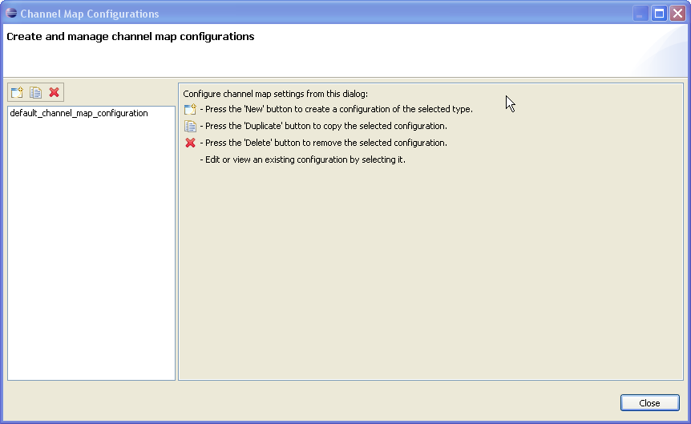
Figure 10: Channel Map Configuration Wizard
- Create a new configuration by pressing the “New” button. This will cause the “Channel Map Configurations” dialog editor to be displayed. Figure 11 shows the expected result of this action.
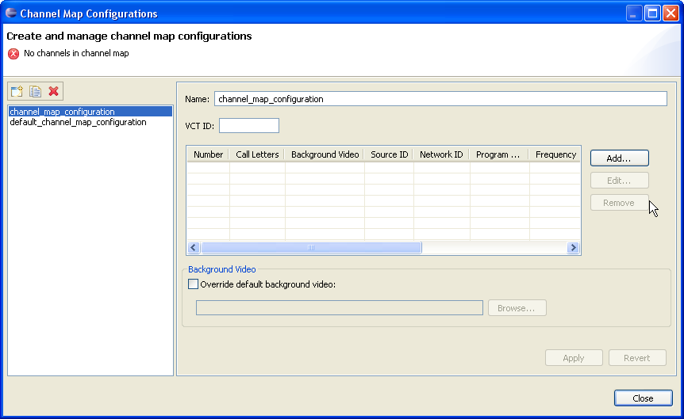
Figure 11: New Channel Map Configuration
- Select the “Add…” button to create new channels. This will need to be done for each channel mapping. Figure 12 shows the entries for the default_channel_map_configuration.
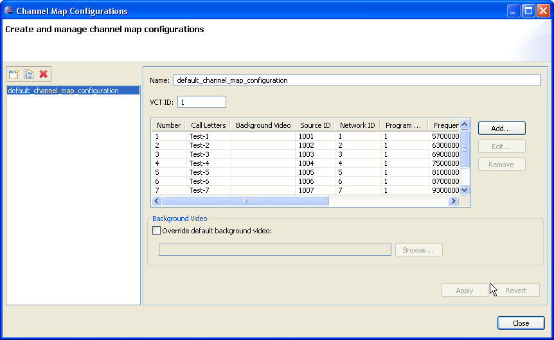
Figure 12: Default Channel Map Configuration
- When you are finished, select “Close”.

Creating a OCAP Simulation Launch Configuration
In order to test an OCAP application in <tru2way> SDK, the application developer must first create an OCAP Simulation launch configuration. This launch configuration will execute the application Xlets associated with the application. The Cable Television Laboratories RI Emulator will be launched by the OCAP Simulation launch configuration.
To create a OCAP Simulation launch configuration, take the following steps:
- Select “Run->Run Configurations…” from the main menu bar. This will bring-up the launch configuration manager as shown in Figure 13.
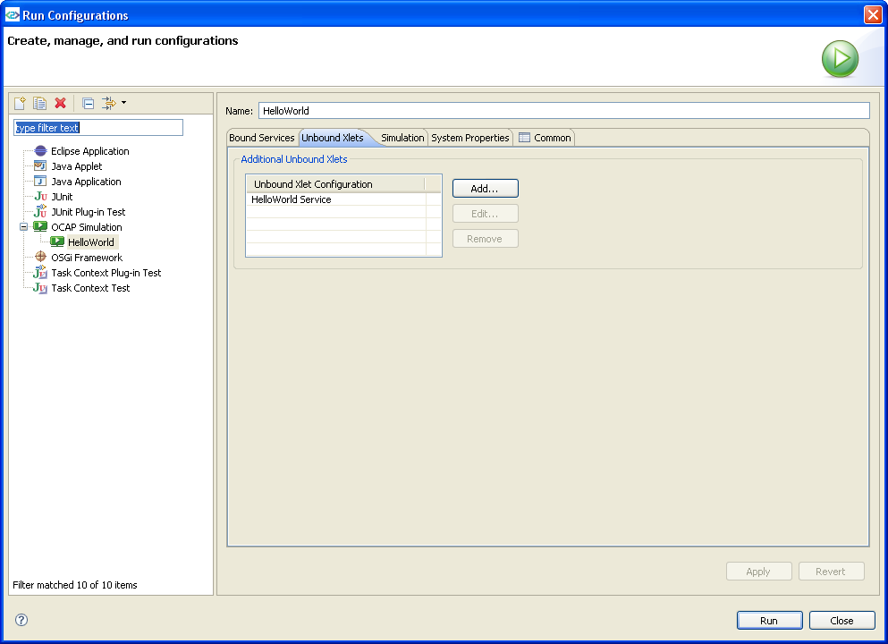
Figure 13: OCAP Simulation Launch Configuration
- On the left-hand side of the “Run Configurations” dialog you should see a list of launch configuration types. Select the “OCAP Simulation” type.
- Press the “New” button to create a configuration of the selected type. This will create the UI tabs necessary for setting up the “OCAP Simulation” launch configuration. You should see four tabs, “Bound Services”, “Unbound Xlets”, “Simulation”, “System Properties” and “Common”.
- For now, the “Unbound Xlets” tab is the only one to be concerned about. Select it.
- Add the Xlets you wish to be executed when the “OCAP Simulation” is launched. This is done by selecting the “Add…” button and identifying the Xlets that were previously configured via the Xlet Service wizard.
- Selecting the “Apply” button will save the launch configuration.
- Selecting the “Run” button will execute the launch configuration. If the Xlet Services were setup properly, then you should see the CableLabs RI Emulator running. It should look something like that shown in Figure 14.
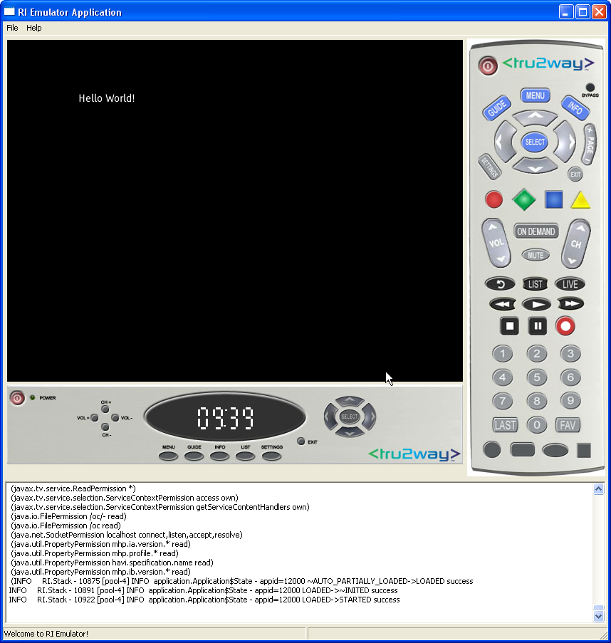
Figure 14: RI Emulator

Creating a OCAP Project Debug Launch Configuration
To debug an OCAP application, the application developer uses the Debug launch configuration. This launch configuration was automatically created when the Run launch configuration was configured above.
The OCAP Project Debug launch configuration is found as follows:
- Select the OCAP Project in the Package Explorer.
- Select the “Run->Debug Configurations…” from the main menu. This will bring up the “Debug Configurations” wizard (see Figure 15).
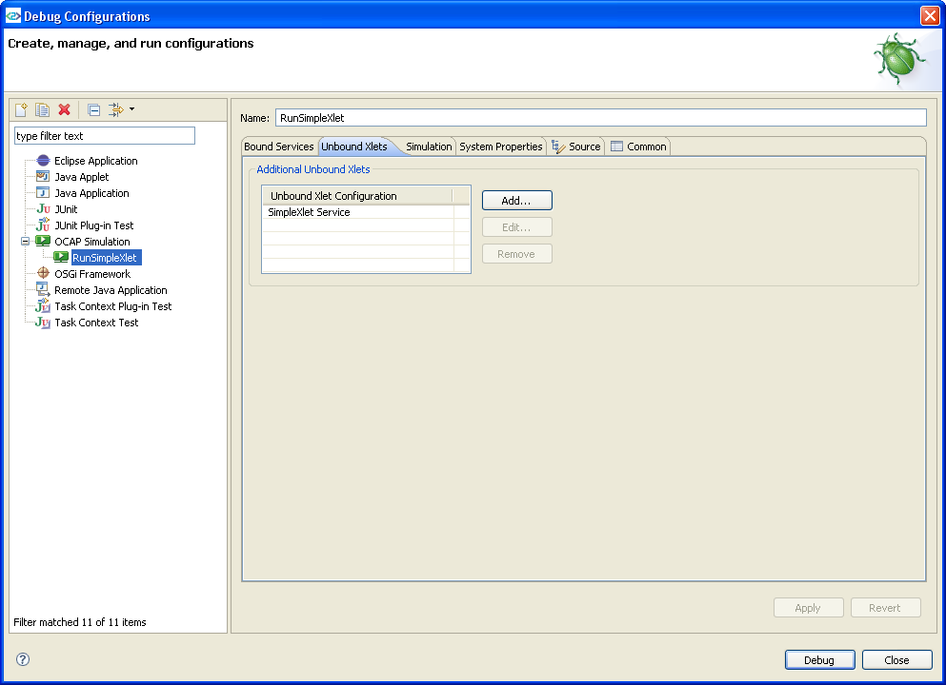
Figure 15: OCAP Project Debug Launch Configuration
- On the left-hand side you should see the list of Debug configurations. There should be an entry under the “OCAP Simulation” category that corresponds to the Debug launch configuration that was created for you. Select it.
- Notice there is an additional tab, “Source”, in the Debug launch configuration. The launch configuration should already be initialized to find the source for your application. The source location was found through the Xlet Service associations registered in the “Unbound Xlets” tab.
- Start a debug session by selecting “Debug”. If any breakpoints have been set in the application source, the Java debugger should break the execution of the code and display the file in the Eclipse Debug Perspective.

Stopping the RI Emulator Session
To stop the RI Emulator, the user must use the “TWB->Stop Emulator” menu entry. Selecting the close icon, “X”, in the emulator window will shutdown the RI Emulator user interface; however, it will not kill the emulator process. Likewise, the “File->Exit” menu entry in the RI Emulator user interface will not properly shutdown the emulation session. You must use the “TWB->Stop Emulator” menu to properly shutdown.
If the <tru2way> SDK IDE thinks the RI Emulator is still running, a warning will be issued. Figure 16 identifies this warning.
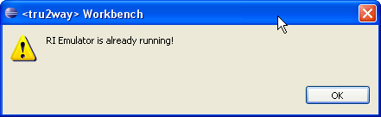
Figure 16: RI Emulator Warning

